**EMAIL MARKETING ANALYSIS   
DASHBOARD IN POWER BI**

DATA CLEANING TOOL USED: **POWER BI**

STEPS DONE TO CLEAN DATA:

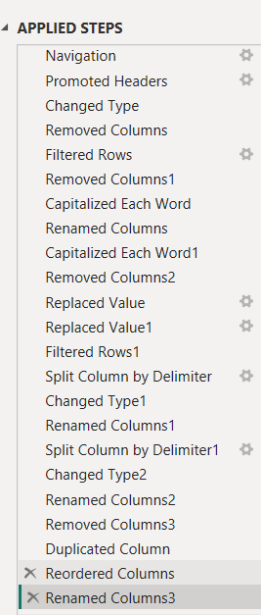

FIRST LOOK AFTER CLEANING DATA:

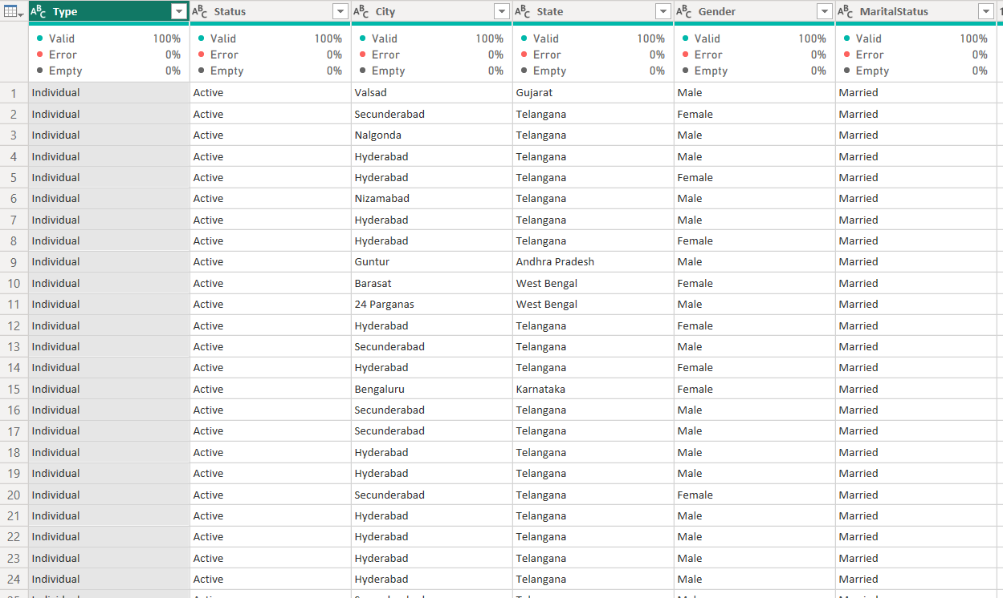

OBJECTIVES/PROBLEM STATEMENT:  
  
1. People Signed up by gender

2. Active user Status

3. People Signed up by Marital Status

4. People Signed up by Living Status

5. People Signed up by State

6. People Signed up by City

7. People Signed up by Year

8. People Signed up by Time

CHARTS USED:

1. DONUT CHART
2. CLUSTERED COLUMN CHART
3. WATERFALL CHART
4. CLUSTERED BAR CHART
5. SLICER
6. CARDS

EXPLANATION:

1. **People Signed up by Gender:** This chart shows the breakdown of signups by gender (Male, Female, Other). The total number of signups is 9,927 with nearly 70% (6,810) being male.
2. **People Signed Up by Activity:** This chart shows the breakdown of signups by whether the user is active or not. Nearly 70% (6,810) of users are active.
3. **People Signed Up by Marital Status:** This chart shows the breakdown of signups by marital status (Married, Unmarried, Single/Living together). Nearly half (4,680) of the users are married.
4. **People Signed Up by Living Status** (This chart title might be misspelt based on the legend). This chart shows the breakdown of signups by living status (Couple with Children, Single/Living together). The data here seems to be incomplete as the total count doesn't match the sum of the two categories.
5. **People Signed up by State:** This chart shows the breakdown of signups by the state where the user lives. Telangana has the most signups (2,130) followed by Maharashtra (1,000) and Andhra Pradesh (200).
6. **People Signed Up by City:** This chart shows the breakdown of signups by the city where the user lives. Hyderabad has the most signups (1,500) followed by Telangana (1,100) and Secunderabad (200). It appears Telangana might be a city, but it is also included in the State chart. There might be some data duplication here.
7. **People Signed Up by Year:** This chart shows the breakdown of signups by the year the user signed up. 2020 has the most signups (3,450) followed by 2019 (2,236) and 2018 (1,157).
8. **People Signed Up by Time:** This chart shows the distribution of signups by the time of the day. There seems to be a spike in signups between 8 AM and 10 AM.

In conclusion, this dashboard provides a quick overview of user signups for your email marketing campaign. It allows you to see trends by demographics, location, and time. You can use this information to understand your target audience better and tailor your marketing campaigns accordingly.

FINAL DASHBOARD:  
